**Ahmed Hassan Ismail – BESE-9B – 237897**

**OS Lab 10**

**Task1**

**Code:**

Given in Lab manual.

**Screenshot:**

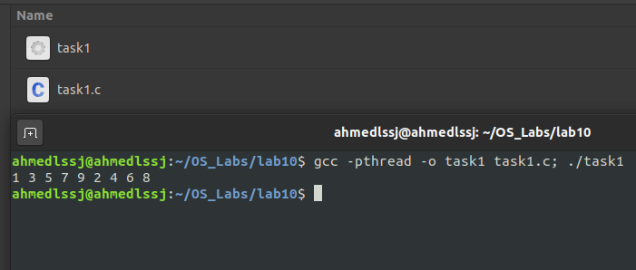

**Task 2**

**Code:**

#include "stdio.h"

#include "stdlib.h"

#include "pthread.h"

pthread_mutex_t count_mutex = PTHREAD_MUTEX_INITIALIZER;

pthread_cond_t condition_var = PTHREAD_COND_INITIALIZER;

int count = 0;

#define COUNT_DONE 10

// Print odd numbers

void *printOddNums()

{

    for (;;)

    {

        // Lock mutex and then wait for signal to relase mutex

        pthread_mutex_lock(&count_mutex);

        if (count % 2 != 0)

        {

            pthread_cond_wait(&condition_var, &count_mutex);

        }

        count++;

        printf("%d ", count);

        pthread_cond_signal(&condition_var);

        if (count >= COUNT_DONE)

        {

            pthread_mutex_unlock(&count_mutex);

            return (NULL);

        }

        pthread_mutex_unlock(&count_mutex);

    }

}

// print even numbers

void *printEvenNums()

{

    for (;;)

    {

        // Lock mutex and then wait for signal to relase mutex

        pthread_mutex_lock(&count_mutex);

        if (count % 2 == 0)

        {

            pthread_cond_wait(&condition_var, &count_mutex);

        }

        count++;

        printf("%d ", count);

        pthread_cond_signal(&condition_var);

        if (count >= COUNT_DONE)

        {

            pthread_mutex_unlock(&count_mutex);

            return (NULL);

        }

        pthread_mutex_unlock(&count_mutex);

    }

}

int main()

{

    pthread_t thread1, thread2;

    pthread_create(&thread1, NULL, &printOddNums, NULL);

    pthread_create(&thread2, NULL, &printEvenNums, NULL);

    pthread_join(thread1, NULL);

    pthread_join(thread2, NULL);

    printf("\n");

    exit(0);

}

**Screenshot:**

